

**CEN 308 SOFTWARE ENGINEERING**

PROJECT DOCUMENTATION

Teach Me

Prepared by:

**Admir Šahman**

**Semir Šahman**

Proposed to:

**Nermina Durmić, Assist. Prof. Dr.**

**Aldin Kovačević, Teaching Assistant**

20/06/2021

Contents

1. Introduction 3

1.1. About the Project 3

1.2. Project Functionalities and Screenshots 3

2. Project Structure 8

2.1. Technologies 8

2.2. Database Entities 8

2.3. Architectural Pattern 9

2.4. Design Patterns 9

3. Conclusion 9

# 1. Introduction

This document represents the basic template of the documentation that you need to submit along with your project. Your documentation *should contain* *all the content* that is mentioned here. However, if you want to add additional sections to the document, rearrange it or redesign it, you are welcome to do so, as long as you keep all of the content that is required here.

There will not be a separate LMS submission for the documentation. Instead, you will add this documentation file to your *project repository on GitHub* once you are done.

As a final note, before submitting your final project version, go over the [project requirements](https://docs.google.com/document/d/1IFsQ4zHoXjq4f_xMKOwe13WdXSAMbZzWY7Rj5tk1nhs/edit?usp=sharing) one more time and make sure that your project was done in accordance with them. You may delete these three paragraphs in your final document.

## 1.1. About the Project

One place to find all learning materials for different topics divided by categories. This platform will provide users to have access to various books and learning materials for lower price than other systems with a lot of free content.

**Project URL:** teachme-se.herokuapp.com/

## 1.2. Project Functionalities and Screenshots

* **Login**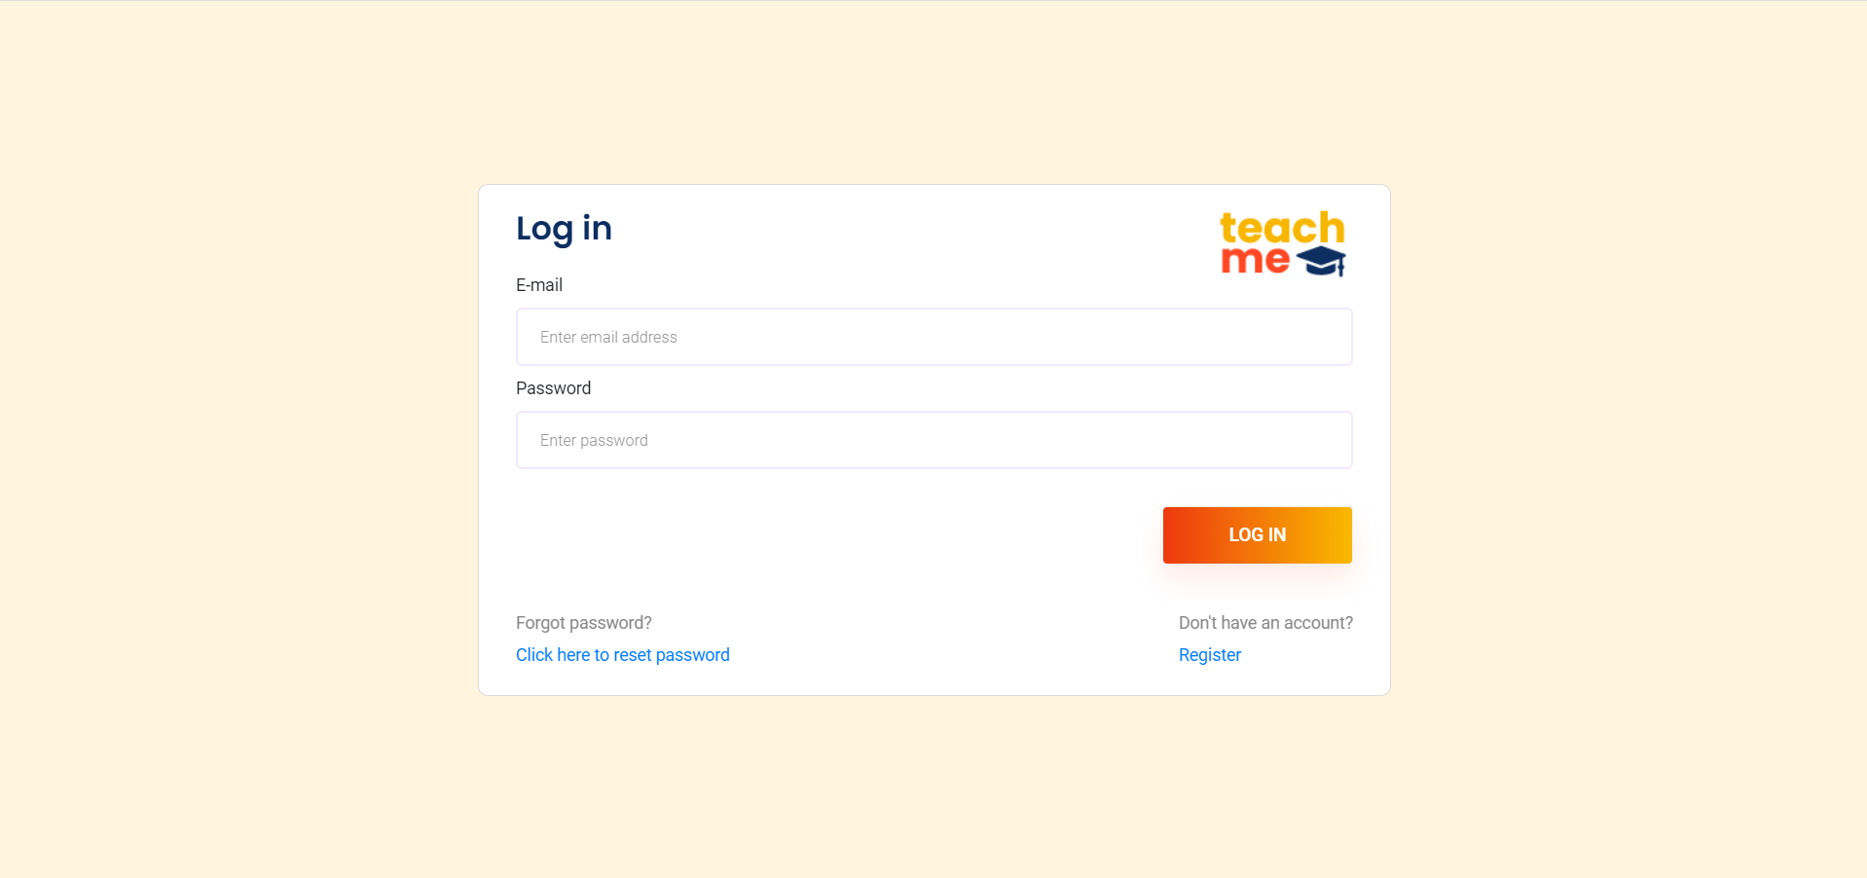
* **Register**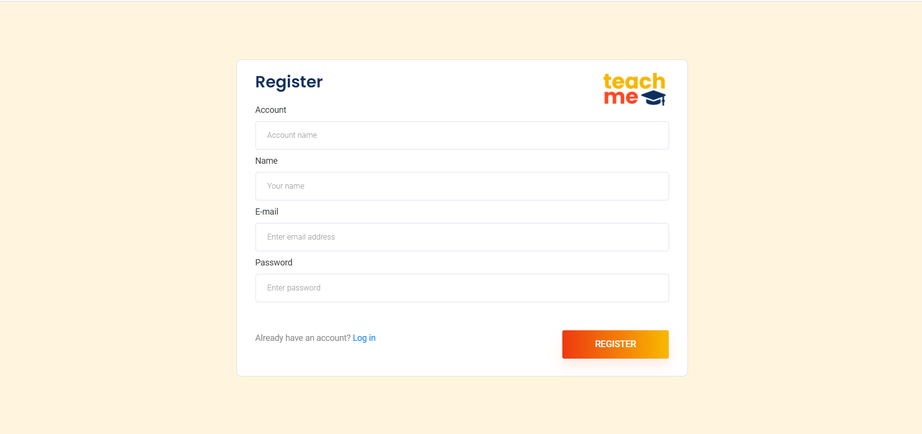
* **Forgot password**

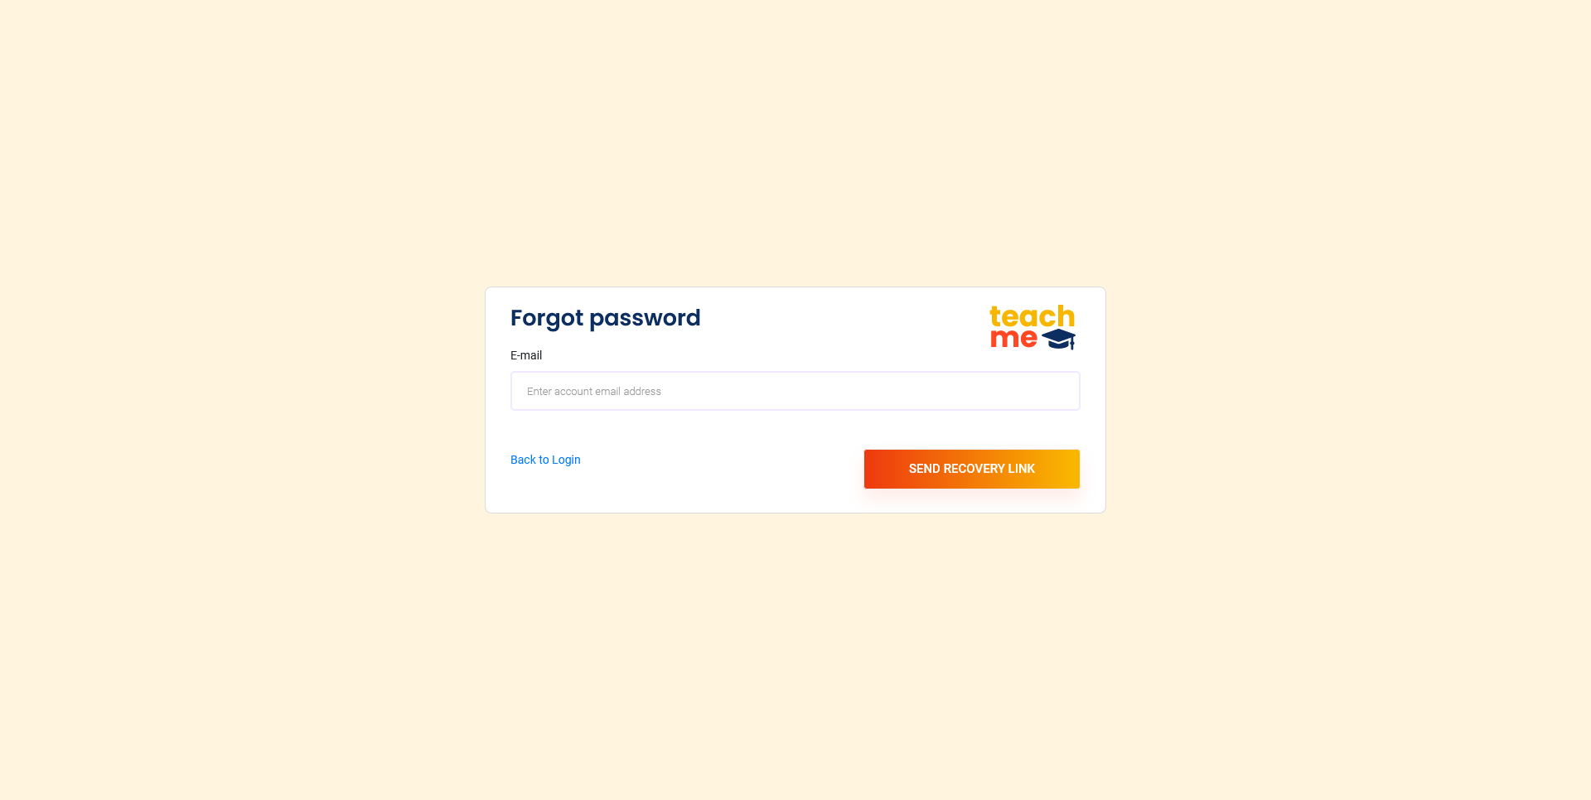

* **Change password**

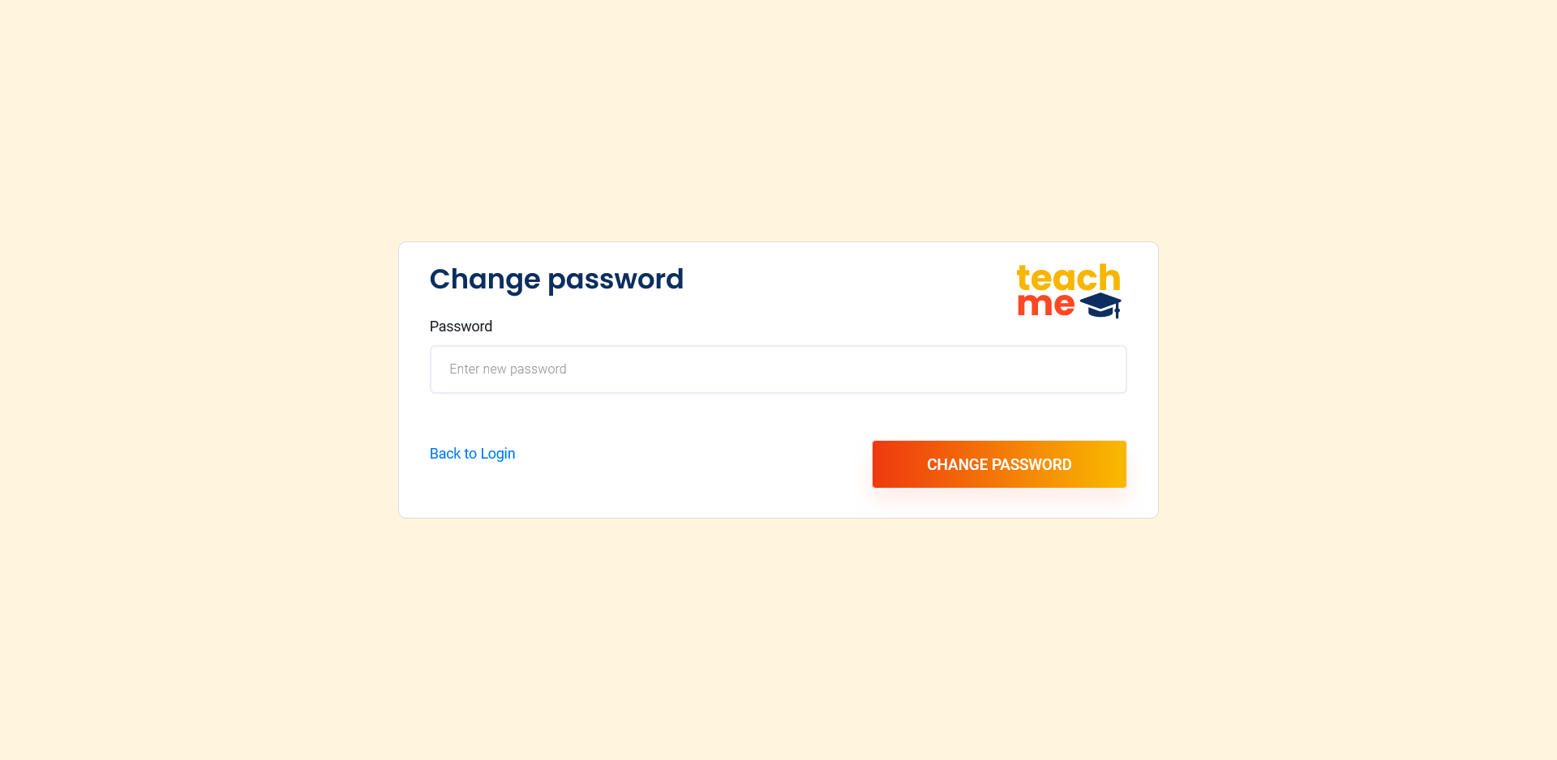

* **Home**  
  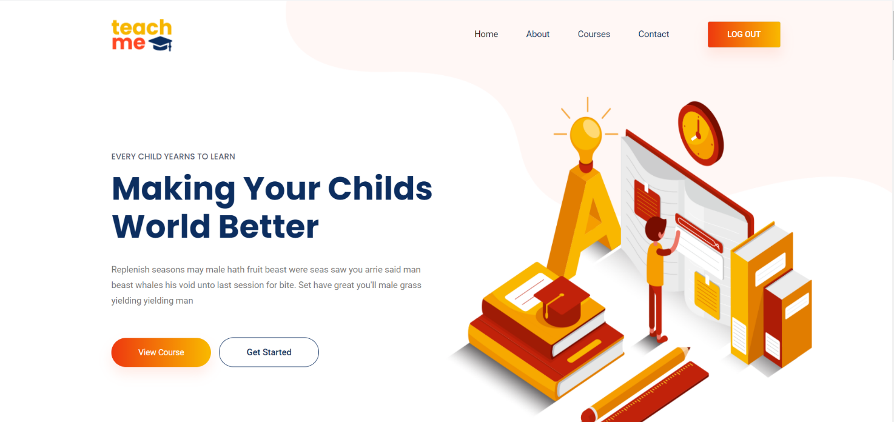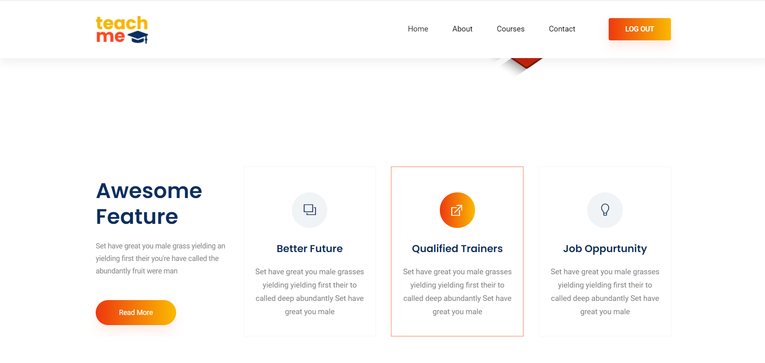
* **About us**  
  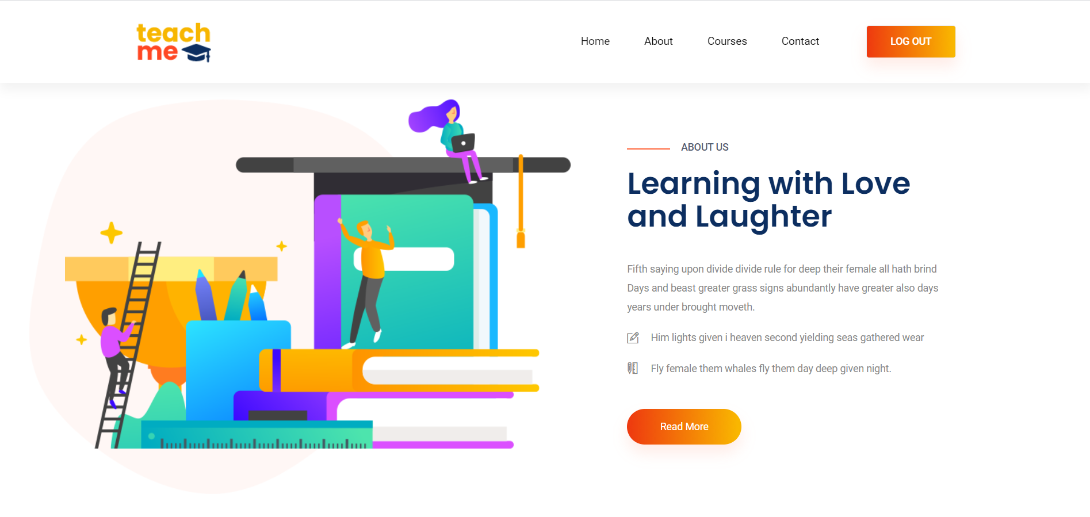  
  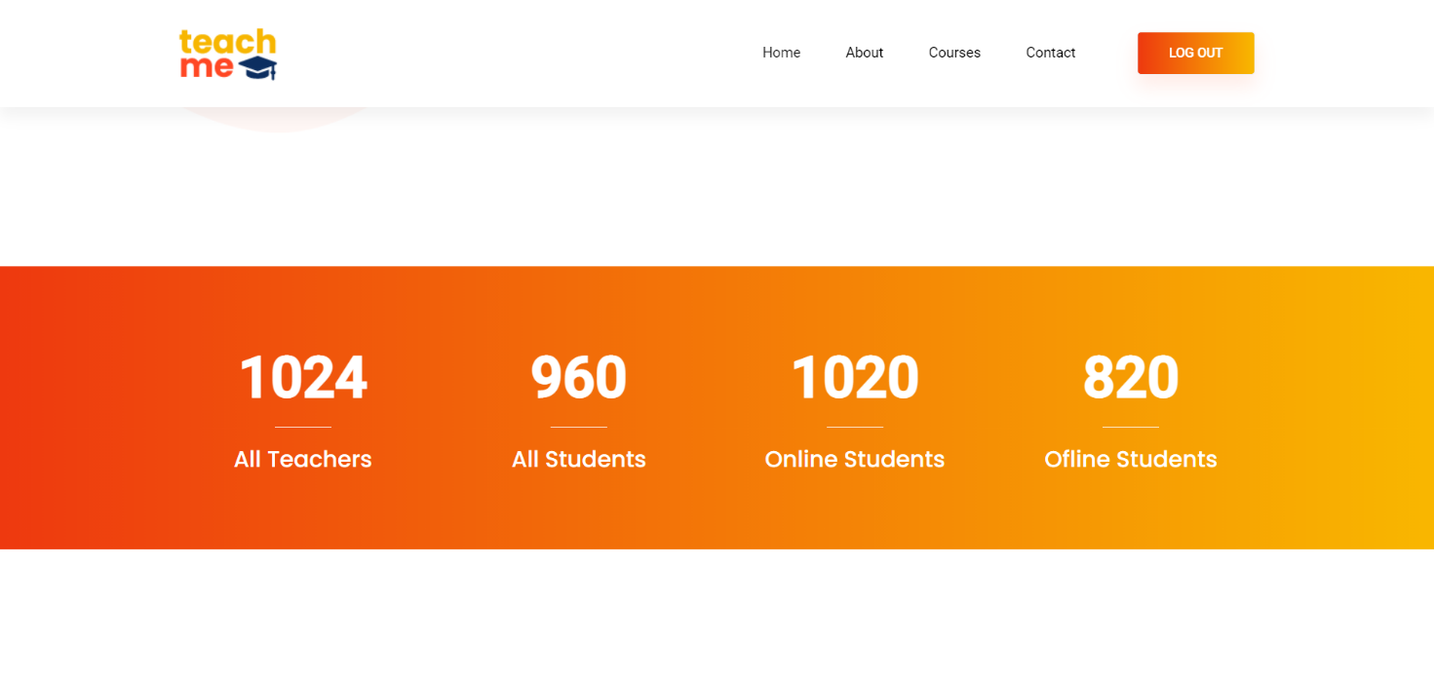
* **Courses**  
  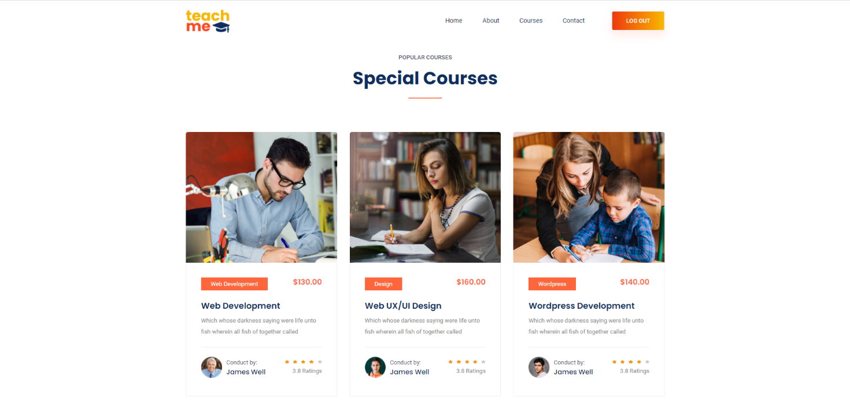
* **Contact us**  
  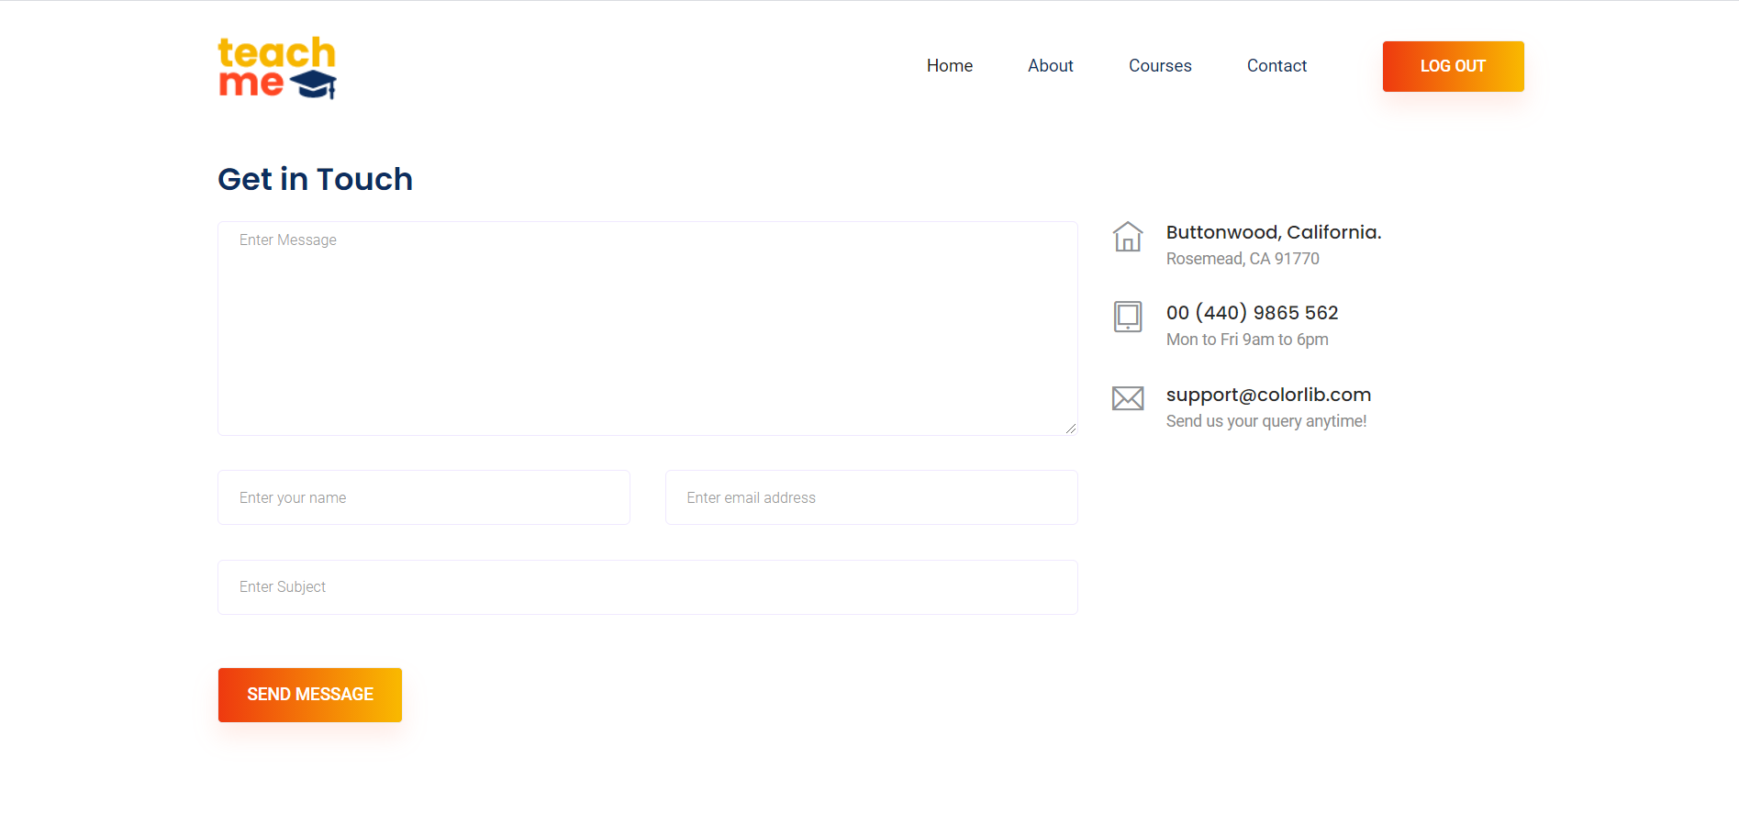
* **Newsletter**  
  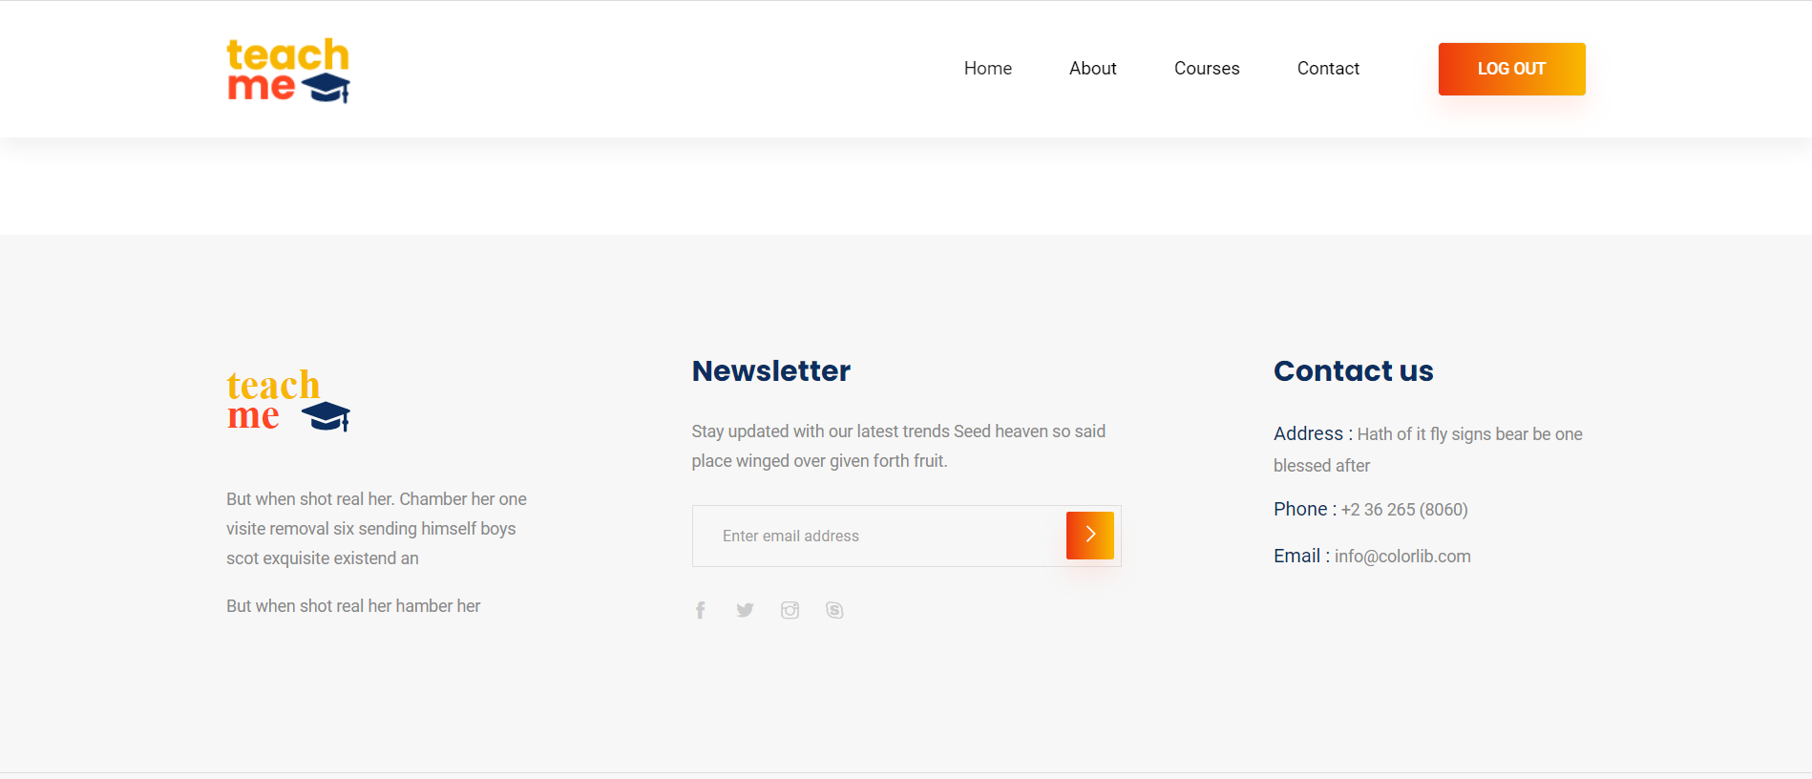

# 2. Project Structure

## 2.1. Technologies

Our project was developed in WAMP stack. For backend we used PHP and on frontend we used PHP along with HTML and CSS. For database we used MySQL.

Coding standard – PSR-1

## 2.2. Database Entities

* accounts
* courses
* student_course
* student_course_taken
* students
* teachers
* users

## 2.3. Architectural Pattern

Since we are using WAMP stack we have Windows at the lowest level with layered architecture. After Windows we have Apache and MySQL. At the next stage comes PHP. The process begins with requests for webpages from a user’s browser being submitted to the Apache webserver. Apache transfers the request into PHP to load the file and run the code stored in it, if the request is for a PHP file. PHP also interacts with MySQL to capture some data in the code. In order to build the HTML that browsers use to view web pages, PHP then uses code in a file and the database details.

## 2.4. Design Patterns

We used singleton design pattern for the purposes of this project. We used the singleton design pattern so that we can gain a global access point to our instances.

# 3. Conclusion

It was a challenging task to do, but overall it significantly improved our skills. It gave us an ability to apply our theoretical knowledge in practical work.